You have been chosen by Norwalk Public Schools to research and design a common craft video to be presented to 7th grade students at the other 3 middle schools. In your video you will discuss and show a visual representation of these topics.
How will your video progress?
Introduction of your civilization (what is the name of your civilization?)
Where is your civilization located? (compare your civilization to the other civilizations)
What type of religion did they have? (what were some of the beliefs/customs)
One aspect of life- (Sports, Government, Weapons, Food, Agriculture, Clothing)
What were their major accomplishments? (you should discuss at least 3)
End the video with a slogan of what make your civilization the best!
Video component
1. Start with Title Slide that has your civilization name and the names of the people in your group
2. You should have a Map that is colored in and labeled with the location of your civilization.
3. You should have hand-drawn pictures that help support your information on Religion.
4. You should have hand-drawn pictures that help support your information on the Major Accomplishments.
5. You should have pictures that support life in the civilization.
6. A Slogan that explains why your civilization is the best!
7. What eventually happened to your civilization?
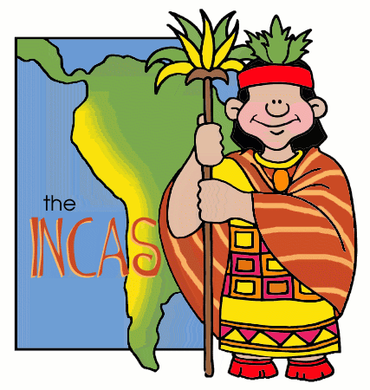
See Rubric
